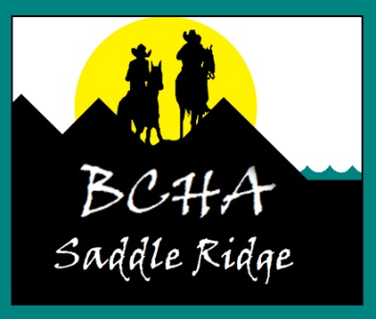 BHK Saddle Ridge December meeting agenda
Thursday, January 13th Marysville Township Hall 216 Central, Hillsdale, KS
Call to Order
Minutes from the October mtg- Lacole
Treasurer’s Report—Nancy
Trails Report- Kayla
Old Business
Update on approved bench- Kayla and Farley
Corrals for campground- Stephanie
Equifest interest
ByLaws Committee Report- Kayla, Debbie John

- Renewal membership for 2022 process
- January annual meeting in Council Grove, KS
- Decide on meeting dates, event dates, trail dates for 2022
- Vote for President and Vice President

New business
Adding LaCyne trails to Saddle Ridge BCH KS endeavor?

